Scientific Importance. The understanding of unknown nature of Dark Matter (DM) is one of the outstanding problems in the focus of the Cosmic Frontier of the particle physics research [1]. Not all proposed hypothetical DM models are directly testable. Thus, the popular Super-Symmetry theory that predicted a lightest heavy super-symmetric particle to be the particle of DM was not confirmed [2] at LHC-collider. Another viable DM candidate axion particle have been searched for decades without success [2]. Our experiments with cold neutrons explore another viable and testable DM model, the model where DM consists of “Mirror Matter” (MM) particles [3]. This MM is an exact copy of the Ordinary Matter (OM) with the same interactions and same particle content but non-interacting with the OM except only via gravity. In this model the neutron $\left(n\right)$as a neutral particle can be transformed [4] by oscillation to its twin in the mirror sector, the “mirror” neutron ($n')$, which, being a dark matter particle, is not visible by the OM detectors. One version of this MM model [5] conjectures that masses of $n$ and $n'$ are not exactly degenerate due to possible difference between vacuum expectation values in OM and MM sectors. That provides [5] the possible explanation of the neutron life-time anomaly [6]. This explanation was refuted by us in the previous SNS-based experiment published in PRL [7]. With the GP-SANS-based experiment proposed here we will search for the neutron Transition Magnetic Moment ($n$TMM) an electromagnetic property of $n→n'$ transformations in the MM model with degenerated masses [8]. This model provides an alternative explanation of the neutron lifetime anomaly. It is well known that TMM exists for specific transitions of neutral particles e.g., in the processes $Σ^{0}→Λ^{0}+γ$ [9] and in the flavor oscillations of the neutrino [10]. The $n$TMM is a specific magnetic moment $η$ due to transformations $n↔n^{'}.$ Its magnitude is not a priori known but can be a small fraction of the regular neutron dipole magnetic moment $μ$.
The determination of the neutron lifetime and the resolution of the lifetime anomaly, i.e. the discrepancy between two state-of-the-art methods of $n$ lifetime measurements, formed the basis of one of the highest scientific priorities recommended by the NSAC Subcommittee to Fundamental Nuclear Physics with Neutrons [11] ahead of the development of DOE NP’s 2015 Long Range Plan for Nuclear Science [12]. In addition, the HEP community has highlighted the importance of pursuing all feasible avenues to search for dark matter candidates based on other unanswered questions in physics [1, 13]. Also, the broader program of neutron oscillations was featured as a key Frontier sub-topic in the APS DPF Snowmass Community Planning Process [14]. Building on the success of the Fundamental Neutron Physics Beamline at SNS, COHERENT [15] and PROSPECT [16] experiments, ORNL Physics Division is pursuing this research area as a new initiative to expand the fundamental physics program at ORNL’s neutron facilities. The SNS and HFIR can be applied to dark matter research and these benefits should be assessed, as recognized in the charge to the Basic Energy Science Advisory Committee in 2019 [17]. The lack of observation of a signal consistent with this exotic process is of great interest in ruling out part of the parameter space for dark matter candidates and exotic explanations for the neutron lifetime anomaly.
Preliminary Work. In our previous experiment IPTS-22937 at SNS published in PRL [7] we refuted the interpretation of neutron life-time anomaly through the non-degenerated $∆m≠0$ $n→n'$ oscillation by exclusion the region of parameters where such interpretation was possible. In the scheduled GP-SANS experiments IPTS-27957.2 which is a continuation of the previous IPTS-24916 we are setting high sensitivity upper limits on the possible value of the $n and n'$ mass-difference in the broad range of mixing strength $ϵ$ between MM and OM sectors. Analysis of IPTS-24916 data suggested increasing the detection threshold of GP-SANS detector for the reduction of background in the region of interest to the expected level 0.1 cps.
Choice of Instrument. According to our studies [18-19] the GP-SANS instrument chosen for the current proposal provides high time-averaged intensity, long beam guides and a large area detector with relatively low background, enabling sensitive searches for mirror neutrons. In addition, our team has gained experience using GP-SANS and now have better understanding of its operation and beam character in supporting this type of research. This measurement is the next natural step in a staged campaign to quantify $n→n'$ oscillation limits.
Experiment Plan. Presence of $n$TMM makes the mixing strength of $n→n^{'}$ transformation proportional to the applied magnetic field $B.$ On the another side, the magnetic field $B$, acting only on $n$ but not on $n^{'}$, increases the energy level split between$n$ and $n^{'}$, and thus suppresses the probability of $n→n^{'}$ transition, making such a transition practically independent on the magnetic field, but only on the value of $n$TMM $ηB>ϵ$ To compensate the latter suppression, we plan to apply magnetic field in the air at STP such that the optical potential of air $V≅0.12 neV$ will compensate the energy level split due to magnetic field B$≈20 Gauss$ for one of polarizations of the neutrons in the beam. This can be described by the simplified Hamiltonian shown below for the mixed quantum state of ${\left(n,n^{'}\right)}^{T}$. Here in the case of compensation $V=μB$ the time evolution of ${\left(n,n^{'}\right)}^{T}$ two-level system becomes unsuppressed and amplified by $ηB$. Probability of $n→n^{'}$ in this case has a resonance maximum at $P_{n→n^{'}}≅\sin^{2}\left({ηBt}/ℏ\right)$. To measure the effect of $n→n^{'}$ with $n$TMM we will use method of regeneration. Figure 1 shows the shape of expected regenerated resonance peak in red. We are building two solenoidal 20-Gauss magnets each with the length 1.7 m and ID = 20 cm. These will be installed on the axis of GP-SANS cold beam line. The $n→n^{'}$ transformation will occur inside the first magnet with the estimated probability $≈{10}^{-5}.$Between two magnets there will be installed a plate of 3.5 mm Cd that will absorb all neutron beam (with suppression factor more than ${10}^{20}$) but will pass all mirror neutrons. In the second magnet mirror neutrons $n^{'}$will be regenerated to the ordinary neutrons $n$with the same probability $≈{10}^{-5}$. These neutrons can be detected in the GP-SANS detector as if they were beam neutrons. Switching off the magnetic field in the magnets will remove regeneration effect completely, providing a pure background counting. With the collimated GP-SANS the beam intensity $5×10^{9} s^{-1}$as extrapolated from our previous measurements in IPTS-24916 (full spectrum without velocity selector), we expect that the effect counting rate will be 0.45 regenerated neutrons per second if $η={10}^{-5}μ$. Expected background rate in the GP-SANS detector as determined from our previous measurements in IPTS-24916. Within the region of interest determined by the neutron beam divergence it should be less than 1 cps (0.1 cps is expected). With this level of sensitivity at the peak of the resonance for one hour of continuous beam time we should be able to exclude the effect of $n→n^{'}$ due to $n$TMM with 4$σ significance$down to the level of $κ=η/μ$ < $4∙{10}^{-6}$. This exclusion limit as shown in Figure 2 will exceed the previous estimates [8] of $n$TMM obtained from existing UCN experiments. It will be independent on the assumed in UCN experiments value of the mirror magnetic field present in the laboratories. The finite value of $n$TMM can be used for the explanation of neutron lifetime anomaly [6]. Since both $V$and $μB$will be known with a finite accuracy and other effects like unknown mirror magnetic field might be present, we will need to scan by magnetic field in the range $20±1$Gauss with 12 field values. Each point will require two one-hour runs with magnets ON and OFF for background subtraction. If background rate will be higher than expected 0.1 $s^{-1}$ measurement time will be at least doubled. We request 48 hours of beam time measurements plus 12 hours for initial experiment setting including intensity calibration by gold foil activation and by low efficiency calibrated Lowell monitor. For the detection of regenerated neutrons we propose to use the main GP-SANS neutron detector. Magnetic field of the 20-Gauss magnets will be calibrated vs current off the beam time. We plan providing industrial sensors for recording in DAQ the pressure, temperature, and moisture levels for the control of the air optical potential $V$.
CG2 beam at HFIR currently has an opening $≈1.5$ m in the sample area between the end of the neutron guide vacuum vessel and the detector vessel. The plans of GP-SANS instrument group development include a replacement of the last 2-m long section of the guide with an “experimental table” or a support that will increase the opening to 3.5 m. We assume that this space will be available and plan to use it for the installation of two 1.7-m long magnets operating in air.
Simplified Hamiltonian of two level ${\left(n,n'\right)}^{T }$system  $$H=\left(\begin{matrix}V-μB & ηB+ϵ \\ ηB+ϵ & 0\end{matrix}\right)$$ | 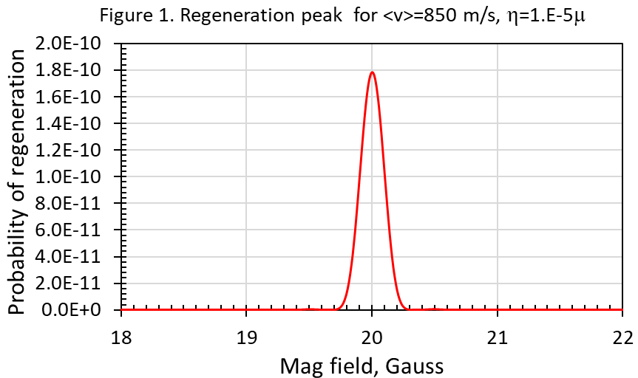 | 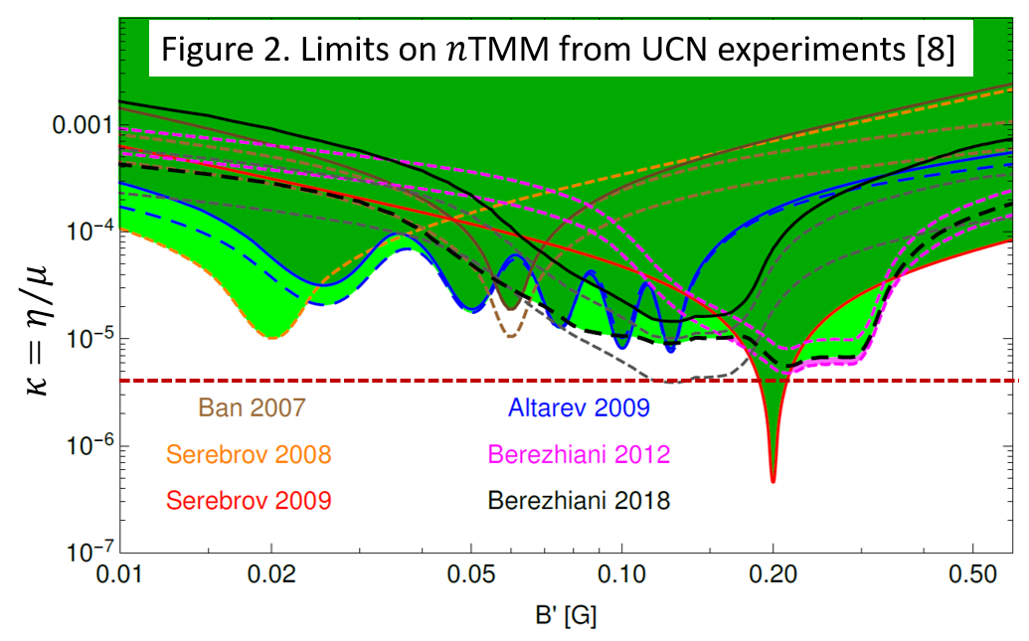
Data Analysis and Scientific Outcome. Standard analysis tools such as Python, ROOT, etc. will be used and have already been developed for EPICS data format. Together with ORNL postdoc the graduate and undergraduate students from the University of Tennessee, and from the collaborating University of Stockholm, Sweden will participate in the data analysis.
The impact of an observation of $n→n'$transformation signal cannot be overstated: it would be the first clues on the particle nature of Dark Matter and completely revolutionize our understanding of the Standard Model of Particle Physics. A positive result from this experiment will lead to the understanding of the neutron lifetime anomaly. A negative result will rule out the $n$TMM model as a possible explanation of this anomaly. If no resonance at $μB=V$ will be observed that will set for the first time a limit on the $n$TMM.

Safety Considerations
This experiment will utilize a high neutron absorption Cd target which may result in radiation hazards. Instructions from radiological control technicians will be followed to implement appropriate safety controls. This experiment will use electrical equipment that may not be NRTL-listed. All non-listed electrical equipment will be inspected and approved by an ORNL Electrical Equipment Inspector before use.

References
1. Proceedings of the 2021 US Community Study of the Future of Particle Physics (Snowmass 2021), https://www.slac.stanford.edu/econf/C210711/.
2. The Review of Particle Physics, R.L. Workman et al. (Particle Data Group), Prog. Theor. Exp. Phys. 2022, 083C01 (2022).
3. A. Berezhiani, Through the Looking-Glass: Alice Adventures in Mirror World, in the book “From Fields to Strings: Circumnavigating Theoretical Physics: A Conference in Tribute to Ian Kogan", 2005, pp 2147-2195, https://doi.org/10.1142/9789812775344_0055.
4. Z. Berezhiani and L. Bento, “Neutron – Mirror Neutron Oscillation: How Fast Might It Be?” Phys. Rev. Lett. 96 081801 (2006).
5. Z. Berezhiani, “Neutron Lifetime Puzzle and Neutron – Mirror Neutron Oscillation,” Eur. Phys. J. C79 (2019) no.6, 484; arXiv:1807.07906 (2018).
6. F. E. Wietfeldt, “Measurements of the Neutron Lifetime,” Atoms 6 70 (2018).
7. L.J. Broussard (Oak Ridge), J.L. Barrow (Tennessee U.), L. DeBeer-Schmitt (Oak Ridge), T. Dennis (East Tennessee State U.), M. R. Fitzsimmons(Oak Ridge and Tennessee U.), M. J. Frost (Oak Ridge), et al., "Experimental Search for Neutron to Mirror Neutron Oscillations as an Explanation of the Neutron Lifetime Anomaly", Phys. Rev. Lett. 128 (2022) 21, 212503, e-Print: 2111.05543 [nucl-ex] (2021).
8. Z. Berezhiani, R. Biondi, Y. Kamyshkov, L. Varriano, “On the Neutron Transition Magnetic Moment,” MDPI Physics 1 (2019) no.2, 271-289, arXiv:1812.11141 (2018).

9. P. C. Petersen, and others, Measurement of the $Σ^{0}→Λ$ Transition Magnetic Moment, (1986), Phys. Rev. Lett. 57, 949.

10. A. de Gouvêa and S. Shalgar, Transition magnetic moments and collective neutrino oscillations: three-flavor effects and detectability, Journal of Cosmology and Astroparticle Physics, Volume 2013, April 2013.
11. Kumar, K.; et al., “Report to the Nuclear Science Advisory Committee: Submitted by the Subcommittee on Fundamental Physics with Neutrons,” (2011). Retrieved from https://science.energy.gov/~/media/np/nsac/pdf/docs/NSAC_NeutronReport.pdf
12. Aprahamian, A.; et al., “Reaching for the horizon: The 2015 long range plan for nuclear science,” (2015). Retrieved from https://science.energy.gov/~/media/np/nsac/pdf/2015LRP/2015_LRPNS_091815.pdf
13. M. Battaglieri et al., “US Cosmic Visions: New Ideas in Dark Matter 2017: Community Report,” arXiv:1707.04591 (2017).
14. J.L. Barrow(MIT), Leah Broussard(Oak Ridge), James M. Cline(McGill U.), et al., "Theories and Experiments for Testable Baryogenesis Mechanisms: A Snowmass White Paper", (Mar 14, 2022), Contribution to 2022 Snowmass Summer Study, e-Print: 2203.07059 [hep-ph].
15. D. Akimov et al., “Observation of coherent elastic neutrino-nucleus scattering,” Science 357 1123 – 1126 (2017), https://arxiv.org/abs/1708.01294.
16. J. Ashenfelter et al., “First search for short-baseline neutrino oscillations at HFIR with PROSPECT,” Phys. Rev. Lett. 121 (2018) no.25, 251802, arXiv:1806.02784 (2018).
17. Basic Energy Science Update at BES Advisory Committee Meeting, March 7, 2019, slides 23-25 “New BESAC Charge from Dr. Binkley (Feb.5, 2019), link.
18. L. J. Broussard, “New Search for Mirror Neutrons at HFIR,” in Proceedings of the 2017 Meeting of the APS Division of Particles and Fields DPF 2017, e-Conf C17-07-31 (2017), https://arxiv.org/abs/1710.00767.
19. L. J. Broussard et al, “New Search for Mirror Neutron Regeneration,” EPJ Web Conf. 219 (2019) 07002, https://arxiv.org/abs/1912.08264.

